ALLERGENS IN OUR CLASS

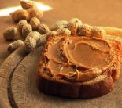 PEANUTS (peanut butter, peanut oil…)

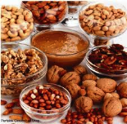 TREE NUTS (cashews, pecans, walnuts, pistachios, brazil nuts…)

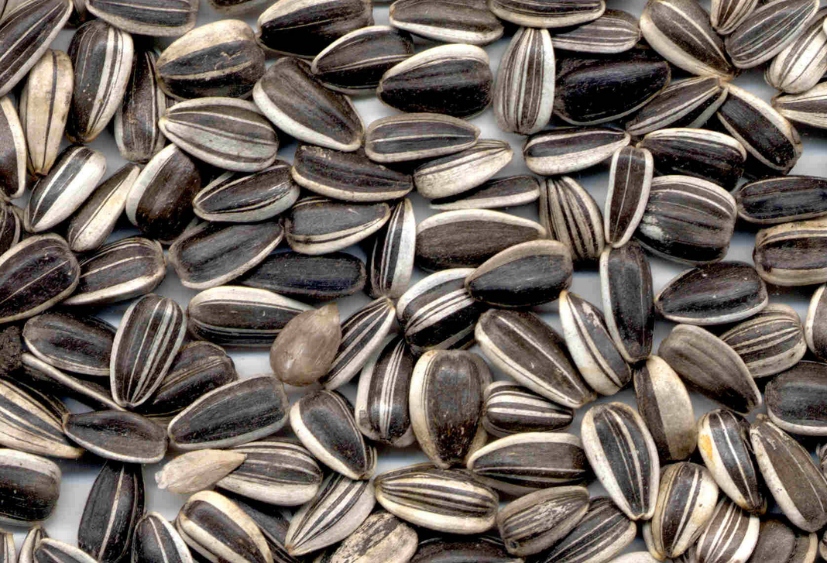 SUNFLOWER SEEDS

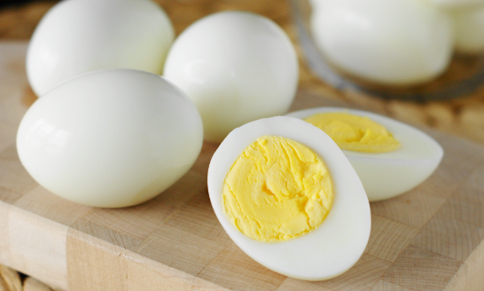 EGGS

Kallan: peanuts, eggs, sunflower seeds (& avoids tree nuts for cross-contamination)

